Guidelines for developing extensions on the FuGE Object Model

Author: Andrew Jones, School of Computer Science, University of Manchester
Email: ajones@cs.man.ac.uk
FuGE URL: http://fuge.sourceforge.net/
Version: Draft guidelines based on the FuGE version 1 (candidate).

- Introduction

The Functional Genomics Experiment (FuGE) model is designed to simplify the process of developing new standard formats for data intensive biological experiments. FuGE is being used by the Microarray Gene Expression Data Society, the Proteomics Standards Initiative and the Metabolomics Standards Initiative. FuGE is also being evaluated in the context of building formats for RNAi, flow cytometry, metagenomics, and immunohistochemistry. FuGE contains models of the components that are common across different types of experiments including experimental protocols, instrumentation, the investigational structure, multidimensional data and materials used in the experiment, such as samples, solutions, whole organisms and so on. In particular the model of protocols, instruments, materials and data is designed to be extended with additional attributes specific to certain a type of experiment in the development of new formats. In this way, data formats for different experimental techniques should contain a shared core structure (based on FuGE) but can be specialized as required. This document is intended to provide guidelines on how to build consistent extensions of FuGE, such that extension developers create new data formats that are as closely related as possible, where the new models represent real world concepts with similar semantics.

In each of the following sections, a class from the model is described that can be extended. The basic functionality of the class is described where it relates to a decision about whether to extend the abstract class (and any abstract associations) or whether to use the generic (non-abstract) version of the class and associations. For the complete description of a class the specification documents should be consulted. Note that these guidelines only describe which classes can be extended and the semantics of extension; a technical description of how to build extensions is provided on the FuGE website (http://fuge.sourceforge.net/). In the text below, classes from FuGE are rendered in fixed-width font.

The key words “MUST,” “MUST NOT,” “REQUIRED,” “SHALL,” “SHALL NOT,” “SHOULD,” “SHOULD NOT,” “RECOMMENDED,” “MAY,” and “OPTIONAL” are to be interpreted as described in RFC-2119 [1].

- Model elements

Protocol
The Protocol class in FuGE describes, for example, lab-book processes, standard operating procedures and data processing pipelines, in terms of the theoretical description of what will be performed. Protocol does not describe the instantiation of that process, which instead is described by ProtocolApplication (see below). A Protocol can be nested to describe complex procedures where the parent Protocol references child Protocols (via Action). A Protocol can also be assigned Parameters, which can have default values.

In addition to the abstract Protocol class that MAY be extended, there is also a non-abstract GenericProtocol class that SHOULD NOT be extended.

Protocol SHOULD be extended to model the semantics a process which will be instantiated separately (potentially multiple times) as a ProtocolApplication and at least one of the following conditions is satisfied:

- A reference is required to specific Actions (either a named association to GenericAction or to a subclass of Action), to describe specific atomic steps or references to child Protocols.
- The Protocol requires associations to specific types of Parameter (either a named association to GenericParameter or to a subclass of Parameter).
- The Protocol requires associations to specific types of Equipment (either a named association to GenericEquipment or to a subclass of Equipment).
- The Protocol requires associations to specific types of Software (either a named association to GenericSoftware or to a subclass of Software).

Action

Action describes steps within a protocol. The difference between Action and Protocol is that Action is intended to describe simple atomic steps, and it cannot be directly associated with Software and Equipment. An Action can be assigned Parameters and can be associated with child Protocols.

In addition to the abstract Action class that MAY be extended, there is also a non-abstract GenericAction class that SHOULD NOT be extended.

Action SHOULD be extended if at least one of the following conditions is satisfied:

- The Action requires associations to specific types of Parameter (either a named association to GenericParameter or to a subclass of Parameter).
- An association is required to a child Protocol (either a named association to GenericProtocol or to a subclass of Protocol).
- The Action requires additional attributes, for example to capture the role or function of the Action with respect to the parent Protocol.

Equipment

Equipment describes all instruments used in an experiment. Equipment can be associated with constituent parts, via the self-association on Equipment, it can be assigned Parameters and it can be associated with specific pieces of Software (to demonstrate that the Equipment relies on a particular Software package.

In addition to the abstract Equipment class that MAY be extended, there is also a non-abstract GenericEquipment class that SHOULD NOT be extended.

Equipment SHOULD be extended if at least one of the following conditions is satisfied:

- The Equipment requires associations to specific types of Parameter (either a named association to GenericParameter or to a subclass of Parameter).
- The Equipment requires associations to specific components (either a named association to GenericEquipment or to another subclass of Equipment).
- The Equipment requires associations to specific types of Software (either a named association to GenericSoftware or to another subclass of Software).

Software

Software describes all pieces of software / computer applications used in an experiment. Software can be assigned Parameters and it can be associated with specific pieces of Equipment (to demonstrate that the Software works in conjunction with or runs a specific piece of Equipment).

In addition to the abstract Software class that MAY be extended, there is also a non-abstract GenericSoftware class that SHOULD NOT be extended.

Software SHOULD be extended if at least one of the following conditions is satisfied:

- The Software requires associations to specific types of Parameter (either a named association to GenericParameter or to a subclass of Parameter).
- The Software requires associations to specific types of Equipment (either a named association to GenericEquipment or to another subclass of Equipment).

Parameter

Parameter describes replaceable values for a Protocol, Equipment, Software or Action.

In addition to the abstract Parameter class that MAY be extended, there is also a non-abstract GenericParameter class that SHOULD NOT be extended.

For certain model developers, it may be advantageous to extend Parameter rather than have a named association to GenericParameter, depending on how the model will be implemented. There is no semantic difference between a named association to GenericParameter and a subclass of Parameter.

Material
Material represents all physical materials including samples, solutions, whole organisms and so on. Materials can be assigned components by the self-association on Material for example to demonstrate an entire population and individuals in the population or a 96-well array and the individual wells.

In addition to the abstract Material class that MAY be extended, there is also a non-abstract GenericMaterial class that SHOULD NOT be extended.

Material SHOULD be extended if at least one of the following conditions is satisfied:

- The Material requires associations to specific components (either a named association to GenericMaterial or to another subclass of Material).
- The Material requires specific attributes or named associations to the Measurement class.

A subclass of Material SHOULD NOT have an association to Parameter, since Parameter has specific semantics that do not apply.

MaterialMeasurement
MaterialMeasurement captures the quantity of a specific Material as input to a ProtocolApplication.

In addition to the abstract MaterialMeasurement class that MAY be extended, there is also a non-abstract GenericMaterialMeasurement class that SHOULD NOT be extended.

MaterialMeasurement SHOULD be extended if the following condition is satisfied:

- The input to a ProtocolApplication is a measured quantity of a specific type of Material (either a named association to GenericMaterial or to another subclass of Material).

ProtocolApplication

ProtocolApplication describes the running or instantiation of a Protocol. ProtocolApplication SHOULD be associated with a Protocol and it can be associated with input or output materials and data.

In addition to the abstract ProtocolApplication class that MAY be extended, there is also a non-abstract GenericProtocolApplication class that SHOULD NOT be extended.

ProtocolApplication SHOULD be extended if at least one of the following conditions is satisfied:

- The ProtocolApplication requires associations to a specific type of Protocol (either a named association to GenericProtcol or to a subclass of Protocol).
- The ProtocolApplication requires associations to a specific type of Material MaterialMeasurement, or Data (either a named association to Generic[Material/InternalData/ExternalData/MaterialMeasurement] or to the equivalent subclasses), to describe that the Material or Data is an input or output of the ProtocolApplication.

Data

Data captures any (multi-dimensional) data sets in the experiment by describing the components in its Dimensions that provide coordinates referencing particular data points within a separate storage matrix. The storage matrix may be captured within the model (InternalData) or in a separate file referenced by URI (ExternalData).

The classes InternalData and ExternalData MAY be extended, the classes GenericInternalData and Data SHOULD NOT be extended.

InternalData or ExternalData SHOULD be extended if at least one of the following conditions is satisfied:

- The Data requires associations to subclasses of Dimension.

InternalData SHOULD be extended if at least one of the following conditions is satisfied:

- A particular format or representation of the storage matrix is required e.g. base64 binary (other than the default storage mechanism in GenericInternalData).

Dimension

Dimension represents one axis of a multi-dimensional data set, for example a microarray data set could contain three Dimensions: i) the array features, ii) a time course experiment measured across multiple assays on the array and iii) the measurements made for array features.

Dimension is abstract and there is no corresponding non-abstract class. Dimension should be extended to capture all multi-dimensional data sets if at least one of the following conditions is satisfied:

- If the Dimensions of the data set should be explicitly described in the format, such that a standard API can be used to access individual data points within the storage matrix.
- If an association is required from a subclass of DataPartition or GenericDataPartition to Data and DimensionElement, such that the experimental variables (modeled by Factor and FactorValue in the Investigation package) can be associated with the subsets of Data with which they correspond.

DimensionElement

DimensionElement describes individual points on an axis (Dimension) of Data. An example of DimensionElement from microarray analysis would be a feature on an array (from the feature Dimension), or the absolute fluorescence value (from the quantification Dimension).

DimensionElement is abstract and there is no corresponding non-abstract class. DimensionElement should be extended if at least one of the following conditions is satisfied:

- If Dimension has been extended, and explicit data points within that Dimension must be represented.
- If an association is required from a subclass of DataPartition or GenericDataPartition to DimensionElement, such that the experimental variables (modeled by Factor and FactorValue in the Investigation package) can be associated with the parts of data with which they correspond.

DataPartition

DataPartition represents a subset of Data, by referencing the Data object that represents the entire data set and the DimensionElements (potentially across multiple Dimensions) that apply for the subset.

In addition to the abstract DataPartition class that MAY be extended, there is also a non-abstract GenericDataPartition class that SHOULD NOT be extended.

DataPartition SHOULD be extended if at least one of the following conditions is satisfied:

- If an association is required to specific subclasses of DimensionElement, for example if the DataPartition can only correspond with a certain type of DimensionElement (such as the array features).
- If an association is required to specific subclasses of Data, for example if the DataPartition can only correspond with a certain type of Data.

PartitionPair

PartitionPair is referenced by a ProtocolApplication for relating subsets of output Data to subsets of the input Data, for example to demonstrate that specific values in the output rely on specific values of the input.

PartitionPair is abstract and there is no corresponding non-abstract class. PartitionPair should be extended if the following condition is satisfied:

- If an association is required to specific types of DimensionElement (either a named association to GenericDimensionElement or to a subclass of DimensionElement).

ConceptualMolecule
ConceptualMolecule represents database entries or “theoretical” representations of molecules, such as biological sequences (as opposed to the physical representation of a molecule), which should be represented by Material.

ConceptualMolecule is abstract and has a non-abstract subclass Sequence to represent biological sequences such as polypeptides or DNA sequences. There are no restrictions on how ConceptualMolecule should be extended, possible extensions include models of metabolites, lipids, chemical entities and so on.

HigherLevelAnalysis

HigherLevelAnalysis represents additional analyses on Data produced from an experiment, such as hierarchical clustering, data mining and so on. HigherLevelAnalysis is abstract and there are no restrictions on how it should be extended.

- Building a root structure for the format

The FuGE class represents a root of the format for the XML implementation, providing references to the Collection classes that have composite associations to all other objects. The FuGE class MAY be extended if the new model requires a reference to all Collection classes, and a new name is required for the root of the format. However, in most cases, it is envisaged that new models will create a new root class (as a subclass of Identifiable), with associations to the Collection classes that are required. New classes associated from the new root class MAY be created, for example to group certain classes that share particular semantics. The example below show the FuGE root (Figure 1), and the root structure from GelML (Figure 2), where the GelML root class references new classes to group together certain types of ProtocolApplication which are related to each other. This design enables the creation of a more intuitive XML implementation.

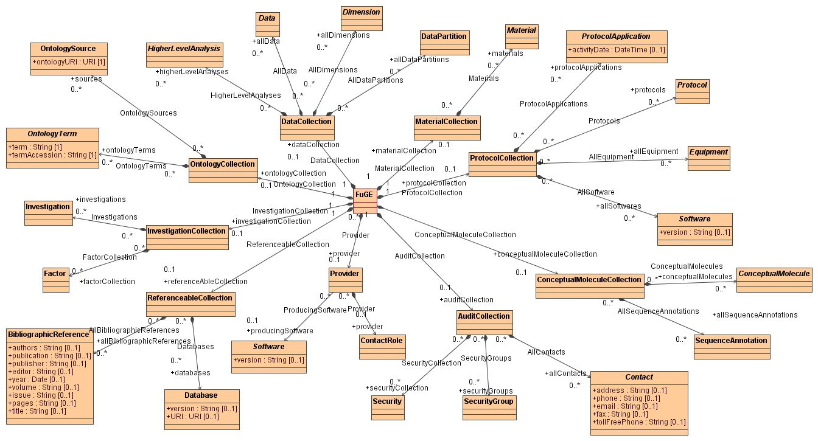
Figure 1 - The FuGE class acts as a root of the core FuGE model.

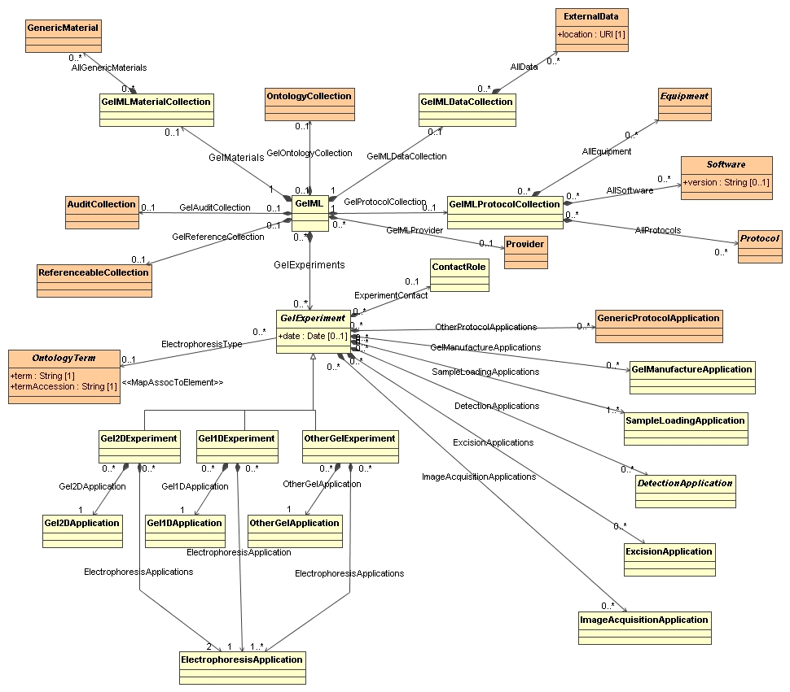
Figure 2 - The GelML class is the root of the GelML format. It has references to particular FuGE classes (brown) and certain newly created Collection classes in GelML (yellow).

- Extending from other parts of FuGE

If an additional class is added to a model that does not fit the semantics of one of the classes listed above, the new class SHOULD be a subclass of Describable (if it is wholly owned by another class and cannot be referenced) or Identifiable (in all other cases). Classes SHOULD NOT be added to the model that do not extend from any FuGE class.

The classes listed above MAY be extended as required, all other classes in FuGE SHOULD NOT be extended.

- References

- Bradner S., Key words for use in RFCs to Indicate Requirement Levels, Internet Engineering Task Force, RFC 2119, http://www.ietf.org/rfc/rfc2119.txt, March 1997.

